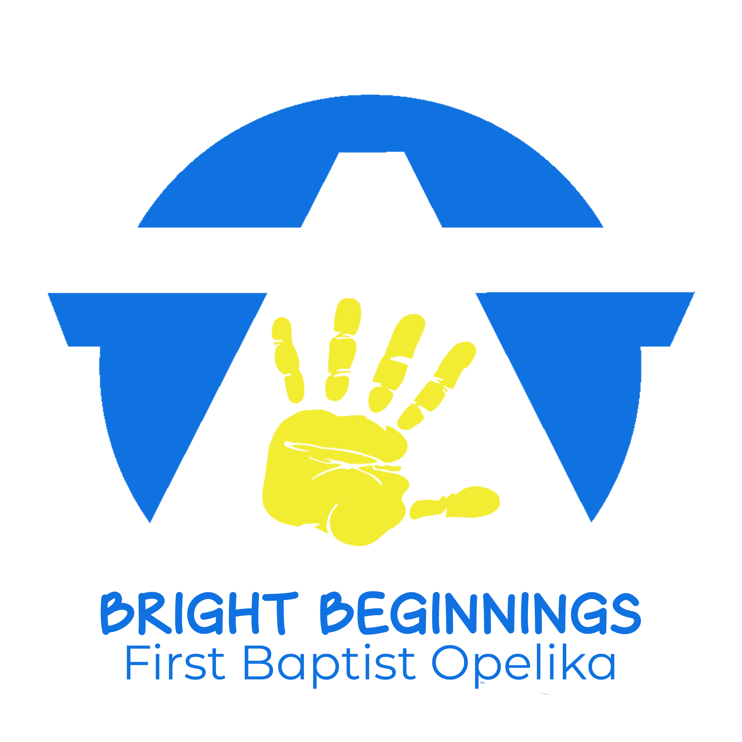
2021-2022
Calendar

August 16-20 Teacher Workdays
August 19 Open House
August 24 1st Day of School (Tuesday)
September 6 Labor Day – No School
September 23-24 Fall Pictures
October 11-13 Fall Break – No School
November 11 Veterans Day – No School
November 24-26 Thanksgiving Holiday – No School
December 10 Christmas Program – 11:00 am
December 13-Jan. 3 Christmas Holidays – No School
January 4 Classes return (Tuesday)
January 17 Martin Luther King Jr Day – No School
February 18 Teacher Professional Development Day
No School for students
February 21 Presidents Day – No School
Feb. 28–Mar. 4 Dr. Seuss Week
March 14-18 Spring Break – No School
March TBA Spring Pictures
April 1 Holiday – No School
April 15 Good Friday – No School
May 13 End-of-Year Program - 11:00 am
Last Day of School

